“Recruit CNY” Job Fair
Over 30 organizations will be on site from Central New York and the Mohawk Valley to fill open positions in finance, civil services, retail, medical, military, insurance and trucking industries
Job Fair takes place at DESTINY USA from 3pm – 6pm on the 3rd Level Canyon
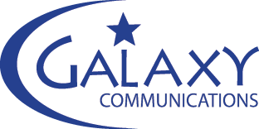
Host: Galaxy Communications Date: April 19, 2017

UPS
Jordan Elbridge CSD
Rapid Response
Arc of Onondaga
Elderwood
Energy Savers
National Guard
US Army
All Metro
Over the Top Roofing
Turning Stone
Bryant and Stratton
DOT Foods
G&C Foods
Drivers Village
Pen and Trophy
Van Duyn
Northwestern Mutual
NY Life
Berkshire Hathaway
Destiny Guest Services
Del Lago
CNY Services
Office of Persons with Developmental Disabilities
Aldi
Just Energy
The Arc OLC
Advanced Business Systems
Aloft Hotel
US Customs and Border Protection
McLane Northeast
Liberty Resources
Community Options
Goodwill
CirCare
CNY Psychiatric

