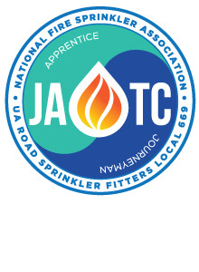

I wanted to notify you of our upcoming interview dates in Central and Western New York.

For those that have filled out an online profile, you will get a phone call one week before the interviews. This is just an early heads up to save the date.

For anyone interested in interviewing, they will need to take the following steps:

1. Go to [www.training669.org](http://www.training669.org)
2. Watch a couple videos under the “Video Section”
3. Select “Getting Started” and check all five boxes
4. Hit continue and select “Complete Profile”
5. Fill out Profile. In the profile it will ask you how you found out about Local 669, please type in: Tim Coleman
6. The candidate will get a NY State One Page Application via email (check your spam folder). This must be filled out and brought to the interview!
7. The candidate will get a call by the first week of February with time on the appropriate date!

February 11th- Rochester, NY Buffalo, NY, Johnston, NY District

February 12th- Syracuse, NY

Text me with questions:

Tim Coleman

315-952-6440

# UA Local 669-JATC interviews dates